Girls On Course
June 2019
Captains Corner
Well firstly I must apologise for the lateness of this newsletter but no excuses it’s here now and the season is in full swing. Lady Captain (2018) Elaine Pritchett has handed over to me and I am going to try hard to live up to her well organised example even if I can’t live up to her excellence on the course.
As you will know there is a packed programme of fixtures some of which have already been played. Spring has been a mixed bag of weather conditions which resulted in a couple of cancellations but it looks as though we are in for a good summer now.
As you know Kim Griffin, my Vice Captain has recently recovered from surgery and we are so glad to see her back on the course again. I really appreciate the wealth of knowledge and experience Kim brings from her previous captaincies and between her and Elaine I am well supported.
We said goodbye to Pat Allen as Committee secretary at the beginning of the season. Pat has produced this newsletter in the past and been the mainstay of the committee for many years. Pat has however agreed to continue to help out at events which is a great relief. Margaret Weston has succeeded Pat as Committee Secretary and she brings a wealth of experience as Past Lady Captain and Secretary from Humberstone Heights.
Friendlies
The Friendly match programme has begun. Unfortunately there was a cancellation by Lingdale on 8th May due to atrocious weather conditions. The match with Melton Mowbray on the 21st May was cancelled by Melton due to a diary malfunction but this has been rebooked for the 30th July. My thanks to the ladies who regularly play in the ‘friendlies’ but if you have never played in one before I do encourage you to give it a try, its usually a very enjoyable day and a good golfing experience. The first friendly of the season was played at Kilworth Springs on 29th May. The ladies had an enjoyable day and my thanks go to Lynda Bramley for standing in for me. The second match, an am-am was played at home with Rothley Park on 4th June and much enjoyed by both teams.
Team Matches
Our ladies, led by Donna Canning, did extremely well to get as far as the second round of the Annodata. I went along to see them at Scraptoft in the first round which they won 3 and 2. Two handicap league matches have already been played against Ullesthorpe and Melton Mowbray. I shall be supporting them in their third league match of the year at home against Willesely Park on 19th June – why not come along and join me the ladies really appreciate your support and you can pick up a lot of handy golfing tips?
Handicaps
As you may know the handicap system will change next year and I am glad to say Elaine Pritchett has joined the handicap sub-committee to help guide the process through. Elaine succeeds Kathy Seal who sadly has left the club for one nearer to her home and we all wish her well but we will be seeing her at Beedles Lake from time to time.
Opens
The 9 hole Open was held on Friday April 5th thus opening the season. 10 teams entered which was considerably down on last year’s 18 teams. As many other clubs have now adopted this format early in the season we are competing for entries. However, it was much enjoyed by those taking part so a big thank you for the delicious cakes and the many lovely raffle prizes which raised £60 for the Captain’s Charity HELP for HEROES.
Lady Captains Away Day
15 ladies joined me at The Nottinghamshire Golf Club on 1st May, an event which had given me a number of sleepless nights in the planning- a nursing and management career did nothing to prepare me for hosting a golfing day with so many experienced and competent golfing ladies. However I needn’t have worried, the weather was fine and the day went well even the discovery of poetry and singing talents within the group! Paula McCourt emerged triumphant in the singles Stableford with Karen Bland as runner up.
Invitation Day. 16 ladies pairs entered and enjoyed the day in good weather. The winners were Paula McCourt and Lorraine Washington Lady Captain Scraptoft Golf Club and runners up Sue Young and Elizabeth Reddick Charnwood Forest. Paula McCourt and Donna Canning were the winners of ‘nearest the pin’ on 3rd and 13th holes. c £90 was raised from the raffle for the Captains Charity.
Diary Dates
Captain Roy Talman and I have arranged Social 9 Holes and supper fundraising night for HELP for HEROES on Friday 5th July at 5pm. The ticket price of £10 per person includes fish and chips after the game, 50% of which will go to the charity. I hope you will join Roy and I in this social event and help support the charity.
I hope you will have a wonderful summer of golf and friendship and I look forward to seeing you on the course.
With Very Best wishes
Sue Bailey
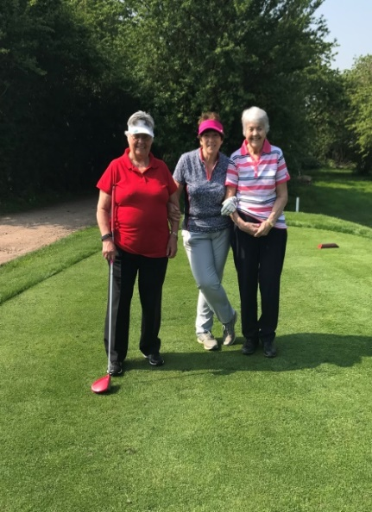
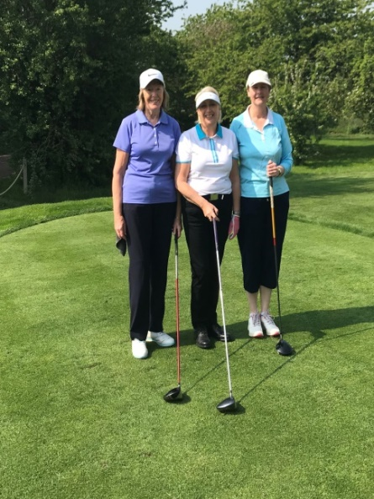
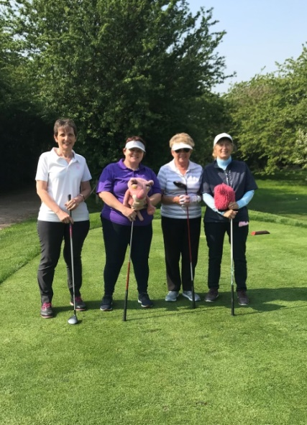
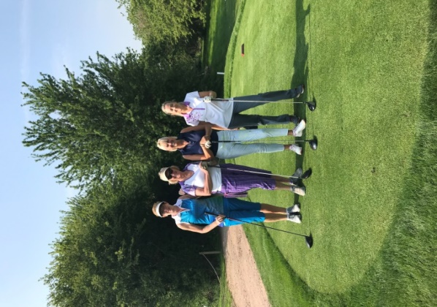
Lady Captain.

