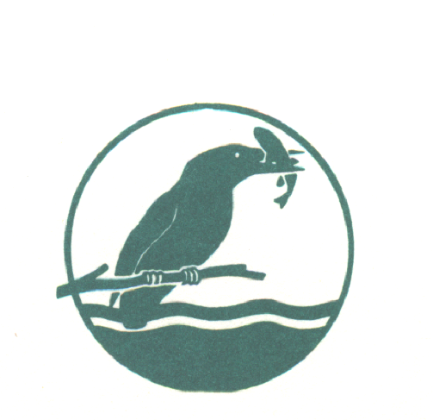
BEEDLES LAKE GOLF CLUB
170 Broome Lane, East Goscote, Leicester. LE7 3WQ
Telephone 0116 2607086
Ladies 9 Hole Open Coffee Morning
FRIDAY 17th APRIL 2020
3 Ball AMAM 2 SCORES TO COUNT 9/10 Handicap allowance 1st tee 9.30a.m
(Maximum 2 Beedles Lake Members per team)
(CDH NUMBER will be required)
ENTRANCE FEE : £27 per team
Includes coffee and cakes post golf & free courtesy round on our Little Owl to be taken on the day
Please complete in block capitals
FULL NAME | CLUB | CDH ID | Handicap

Contact Address (Player 1)..................................................................
..........................................................................Post Code................
Email address.....................................................Tel no.....................
Please make cheques payable to BLGC Ladies Section.
Send your application with a SAE to
Donna Canning 19 Great Lane, Frisby on the Wreake, Melton Mowbray, Leics LE14 2PB
Email – donnamcanning22@gmail.com

