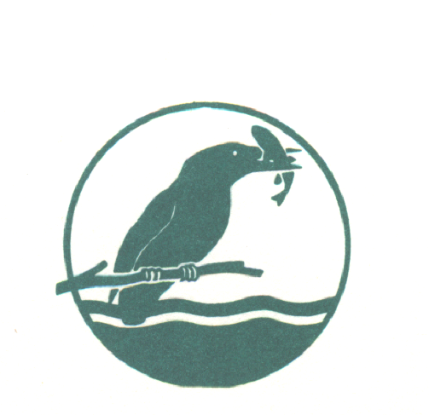
BEEDLES LAKE GOLF CLUB
170 Broome Lane, East Goscote, Leicester. LE7 3WQ
Telephone 0116 2607086
LADIES OPEN
Wednesday 8TH July 2020
No handicap limit 9/10 Handicap allowance
(CDH NUMBER will be required)
4 Ball AMAM
ENTRANCE FEE : £50 PER TEAM
MEALS AVAILABLE
Please complete in block capitals
FULL NAME | CLUB | CDH ID | Handicap

Contact Address (Player 1)..................................................................
..........................................................................Post Code................
Email address.....................................................Tel no.....................
Please make cheques payable to BLGC Ladies Section.
Send your application with a to
Carol Rodgers, 27, Swallow Walk, Hathern ,Leics. LE12 5JF TEL : 01509 733732/ 07855183889 or Book online at www.beedleslake.co.uk and use our BRS visitor booking / open competitions button

