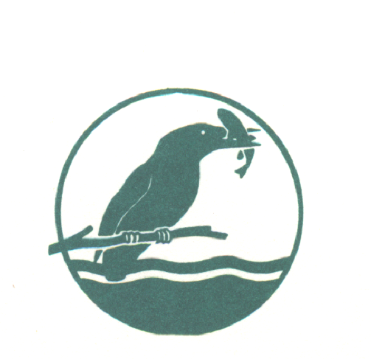
BEEDLES LAKE GOLF CLUB
AUTUMN MEN’S OPEN
BETTERBALL STABLEFORD

SUNDAY 11TH OCTOBER 2020
Visitors entry Fee £30.00 per pair Members Fee £24.00 per Pair
(Prize for best Visiting Pair outside of the main prizes)
Includes: Coffee & Bacon roll on arrival .
Please complete in Capitals in either PAIRS or FOURS
Handicap - 9/10 Handicap allowance | H/C | CLUB and C D H No.
Name
Name
Name
Name
.
Please state 1st / 2nd / 3rd choice of tee time.
9am to 10am | 11am to 12Noon | 12 to 1.00pm
Please send this entry form and a stamped addressed envelope to: THE MEN’S OPEN ORGANISER, together with a cheque made payable to; BEEDLES LAKE GOLF CLUB, 170 Broome Lane, East Goscote, Leicestershire LE7 3WQ or Book online at www.beedleslake.co.uk and use our BRS visitor booking / open competitions button
Contact telephone numbers: 0116 2607086 or 07810852685
Photocopies of this entry form accepted.
Please leave below blank as this will be returned to you confirming your time etc.
CONFIRMATION OF ENTRY
BEEDLES LAKE GOLF CLUB - MEN’S OPEN

SUNDAY 11th OCTOBER 2020- / Betterball Stableford Full Handicap – 9/10 Handicap allowance.
Handicap Certificate Required or CDH number.
Name________________________________________
Your allocated starting time is _______________

Please obtain your Score Card from the Club House and report to the starter 10 minutes before your allotted time. Winners must attend prize giving or be represented.
Dress: Smart casual at prize giving.
COFFEE & BACON ROLL SERVED ON ARRIVAL. CATERING AVAILABLE ALL DAY.

170 BROOME LANE, EAST GOSCOTE, LEICESTERSHIRE LE7 3WQ 0116 2607086

