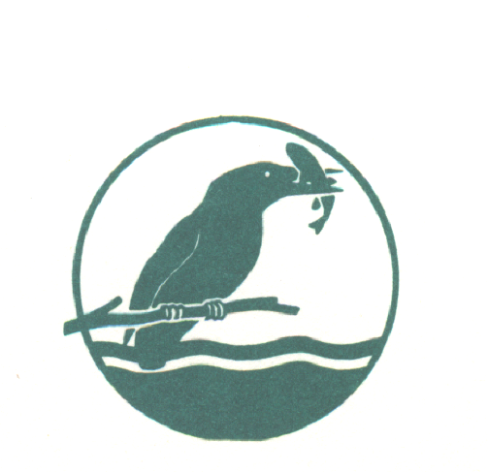
BEEDLES LAKE GOLF CLUB
170 Broome Lane, East Goscote, Leicester. LE7 3WQ
Telephone 0116 2607086
MIXED PAIRS BETTERBALL
SUNDAY 20th SEPTEMBER 2020
ENTRY FEE: £40 PER COUPLE (£32 MEMBERS, £36 MEMBER & GUEST)
Prizes including best visitor score
(1 COURSE CARVERY INCLUDED)
(Please indicate if you have any dietary requirements)
No handicap Limit 9/10 handicap allowance
Please complete in block capitals
GENTLEMAN’S FULL NAME | CLUB | CDH NUMBER | HANDICAP
LADIES FULL NAME | CLUB | CDH NUMBER | HANDICAP

Preferred Start Time: 10.30am – 11.30am 11.30am-12.30pm 12.30- 1.30pm
Contact Name..............................................................................................
Address...............................................................................................
.................................................................Post Code................
Email address...............................................................Tel no.....................
Please return the entry form together with your entry fee
(cheques payable to: BLGC Ladies Section) :
Carol Rodgers, 27 Swallow Walk, Hathern, LOUGHBOROUGH, LEICS. LE12 5JF.
Email: carolrodgers45@gmail.com or or Book online at www.beedleslake.co.uk and use our BRS visitor booking / open competitions button

