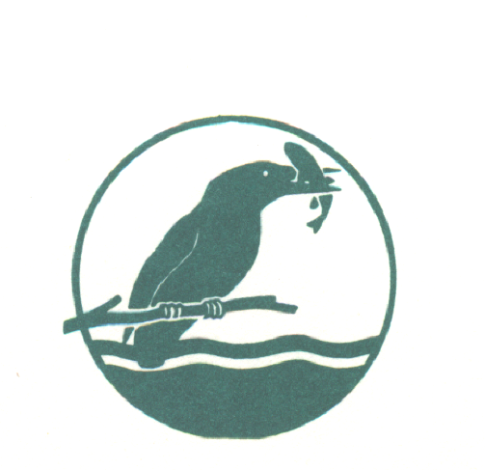
BEEDLES LAKE GOLF CLUB
170 Broome Lane
East Goscote
Leicester LE7 3WQ

Senior Mens Autumn Open
55years and over / Betterball Pairs
Tuesday 6th October 2020
PRIZES FOR BEST VISITOR SCORE IN ADDITION TO MAIN PRIZES

Visitors entry Fee £24.00 per pair Members Fee £20.00 per Pair
Includes: Coffee arrival .
Please complete in Capitals in either PAIRS or FOURS
Handicap - 9/10 Handicap allowance | H/C | CLUB and C D H No.
Name
Name
Name
Name
.
Please state 1st / 2nd / 3rd choice of tee time.
9am to 10am | 11am to 12Noon | 12 to 1.00pm
Please send this entry form and a stamped addressed envelope to: THE SENIORS OPEN ORGANISER, together with a cheque made payable to; BEEDLES LAKE GOLF CLUB, 170 Broome Lane, East Goscote, Leicestershire LE7 3WQ or Book online at www.beedleslake.co.uk and use our BRS visitor booking / open competitions button
Contact telephone numbers: 0116 2607086 or 07810852685
Photocopies of this entry form accepted.
Please leave below blank as this will be returned to you confirming your time etc.
CONFIRMATION OF ENTRY
BEEDLES LAKE GOLF CLUB - Seniors Autumnn Open
TUESDAY 6th October 2020 - / Betterball Pairs Stableford - 9/10 Handicap allowance.
Handicap Certificate Required OR CDH number
Name________________________________________
Your allocated starting time is _______________

Please obtain your Score Card from the Club House and report to the starter 10 minutes before your allotted time. Winners must attend prize giving or be represented.
Dress: Smart casual at prize giving.
COFFEE SERVED ON ARRIVAL. CATERING AVAILABLE ALL DAY.

