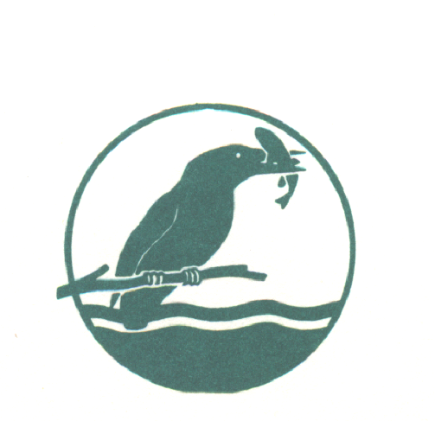
BEEDLES LAKE GOLF CLUB
170 Broome Lane, East Goscote, Leicester. LE7 3WQ
Telephone 0116 2606759
Ladies ‘Guy Fawkes’ 9 Hole Open
Friday 5th November 2021
3 Ball Waltz 85% handicap
(Maximum 2 Beedles Lake Members per team)
ENTRANCE FEE: £42 per team
Includes coffee on arrival. Soup, roll and cake post golf & free courtesy round on our Little Owl to be taken on the day
For Online Booking visit www.beedleslake.co.uk and use the BRS visitor booking / open competitions button
For Postal Entries (with Cheque payable to BLGC Ladies Section)
Please send your application to
Donna Canning 19 Great Lane, Frisby on the Wreake, Melton Mowbray, Leics LE14 2PB
Email – donnamcanning22@gmail.com
NAME | CLUB | CDH ID | WHS

Contact Details (Player 1)..................................................................
Email address.....................................................Tel no.....................

