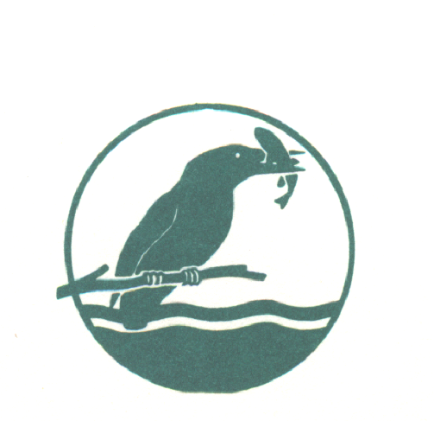
BEEDLES LAKE GOLF CLUB

AUTUMN MEN’S OPEN
BETTERBALL STABLEFORD

SUNDAY 24TH OCTOBER 2021

Visitors entry Fee £30.00 per pair Members Fee £24.00 per Pair

(Prize for best Visiting Pair outside of the main prizes)
Includes: Coffee & Bacon roll on arrival .
Please complete in Capitals in either PAIRS or FOURS
Handicap - 85% allowance | H/C | CLUB and C D H No.
Name
Name
Name
Name
.
Please state 1st / 2nd / 3rd choice of tee time.
9am to 10am | 11am to 12Noon | 12 to 1.00pm

Book online at www.beedleslake.co.uk and use our BRS visitor booking / open competitions button

Contact telephone numbers: 0116 2607086 or 07810852685

.
Please obtain your Score Card from the Club House and report to the starter 10 minutes before your allotted time. Winners must attend prize giving or be represented.
Dress: Smart casual at prize giving.
COFFEE & BACON ROLL SERVED ON ARRIVAL. CATERING AVAILABLE ALL DAY.

170 BROOME LANE, EAST GOSCOTE, LEICESTERSHIRE LE7 3WQ 0116 2607086

