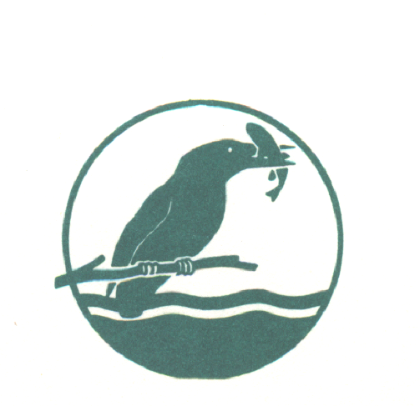
BEEDLES LAKE GOLF CLUB
170 Broome Lane
East Goscote
Leicester LE7 3WQ

Senior Mens Autumn Open

55years and over / Betterball Pairs

Tuesday 12th October 2021

PRIZES FOR BEST VISITOR SCORE IN ADDITION TO MAIN PRIZES

Visitors entry Fee £30.00 per pair Members Fee £24.00 per Pair
Includes: Coffee and Bacon Roll on arrival .
Please complete in Capitals in either PAIRS or FOURS
Handicap - 85% allowance | H/C | CLUB and C D H No.
Name
Name
Name
Name
.
Please state 1st / 2nd / 3rd choice of tee time.
9am to 10am | 11am to 12Noon | 12 to 1.00pm

Book online at www.beedleslake.co.uk and use our BRS visitor booking / open competitions button

Please obtain your Score Card from the Club House and report to the starter 10 minutes before your allotted time. Winners must attend prize giving or be represented.
Dress: Smart casual at prize giving.
COFFEE / BACON ROLL SERVED ON ARRIVAL. CATERING AVAILABLE ALL DAY.

