BEEDLES LAKE GOLF CLUB
170 Broome Lane, East Goscote, Leicester. LE7 3WQ
Telephone 0116 2607086

Come & join us for our
LADIES SPRING OPEN
Wednesday 5th April 2023
Team of 4 Am-Am – best 2 scores (maximum 2 Beedles players per team)
HCP Handicap limit 42
85% Handicap allowance
ENTRY FEE: Visitors £22.50, Members £17.50
Including Afternoon tea
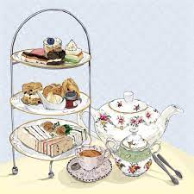
Clothes sale & raffle on the day (proceeds to Alzheimer’s)
Presentation at the end of the Day (No change of attire required)
Book online
www.beedleslake.co.uk and click on BRS visitor booking / open competitions button
or
www. Golfempire.co.uk

