BEEDLES LAKE GOLF CLUB
170 Broome Lane, East Goscote, Leicester. LE7 3WQ
Telephone 0116 2607086

MIXED PAIRS BETTERBALL
SUNDAY 10th SEPTEMBER 2023
ENTRY FEE: MEMBERS £22.50, GUEST £27.50
85% handicap allowance
1 COURSE CARVERY INCLUDED.
(Starter & Pudding menu available on the day if you wish to order)
(Please indicate if you have any dietary requirements)

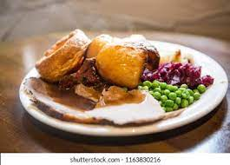

www.beedleslake.co.uk and click on BRS visitor booking / open competitions button
or
www. Golfempire.co.uk

