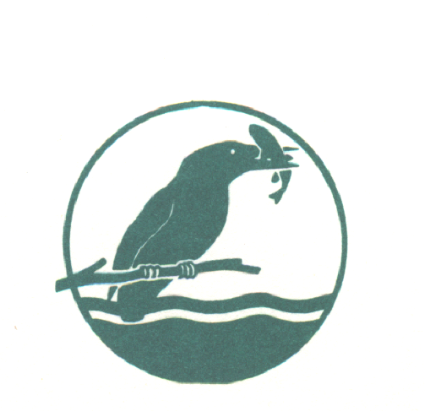
BEEDLES LAKE GOLF CLUB
170 Broome Lane, East Goscote, Leicester. LE7 3WQ
Telephone 0116 2607086

LADIES SPRING OPEN
Wednesday 27th March 2024
Team of 4 AMAM – best 2 scores (maximum 2 Beedles players per team)
HCP Handicap limit 42
85% Handicap allowance
ENTRY FEE: Visitors £22.50, Members £17.50
Includes Afternoon Tea
(selection of sandwiches, scone with clotted cream and a variety of cakes)
Entry Details
Book online
www.beedleslake.co.uk and click on BRS visitor booking / open competitions button
or
www. Golfempire.co.uk

