BEEDLES LAKE GOLF CLUB
170 Broome Lane, East Goscote, Leicester. LE7 3WQ
Telephone 0116 2607086

MIXED AMAM OPEN
SUNDAY OCTOBER 27th 2024
ENTRY FEE: MEMBERS £25.00, GUEST £30.00
Teams of 4, 85% handicap allowance, 1 man and 1 woman to score.
1 COURSE CARVERY INCLUDED.
(Starter & Pudding menu available on the day if you wish to order)
(Please indicate if you have any dietary requirements)

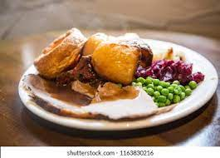

www.beedleslake.co.uk and click on BRS visitor booking / open competitions button
or
www. Golfempire.co.uk

