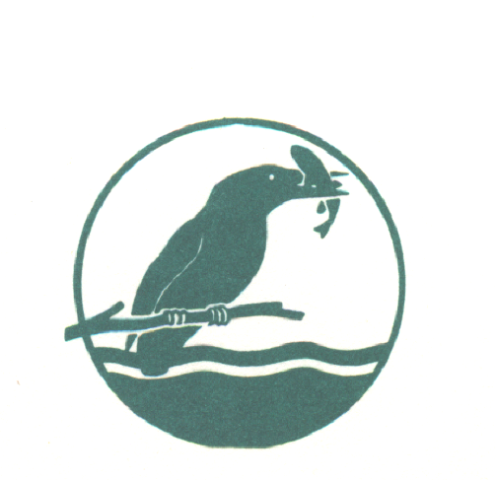
BEEDLES LAKE GOLF CLUB
170 Broome Lane
East Goscote
Leicester LE7 3WQ

Senior Mens Spring Open

55years and over / Betterball Pairs

Tuesday 7th May 2024

PRIZES FOR BEST VISITOR SCORE IN ADDITION TO MAIN PRIZES

Visitors entry Fee £30.00 per pair Members Fee £24.00 per Pair
Includes: Coffee on arrival

All bookings must be made online – www.beedleslake.co.uk

Members Booking Button for members – Open Competitions

Visitors Booking Button for Visitors – Open Competitions

Entry fee must be paid online before tee time accepted

Please obtain your Score Card from the Club House and report to the starter 10 minutes before your allotted time. Winners must attend prize giving or be represented.

Dress: Smart casual at prize giving.

COFFEE SERVED ON ARRIVAL. CATERING AVAILABLE ALL DAY.

